**COMP 4964 – Lab 3**

**Docker Introduction**

In this lab, you will use CloudShell as our host, since it has Docker installed, so you don’t need to do much installation and configuration. Then you may focus on learning Docker skills.

# Part 1 - Docker Hub

Create your own Docker Hub account here: <https://hub.docker.com>. This repository is like GitHub, except it is for Docker images, not software (coding) projects.

This is a place to download and upload Docker images. You can create both public and private repositories. You are allowed one, free private repository with multiple public repos.

Below is Bill’s Docker Hub repositories. He has five public repositories and one private repo.

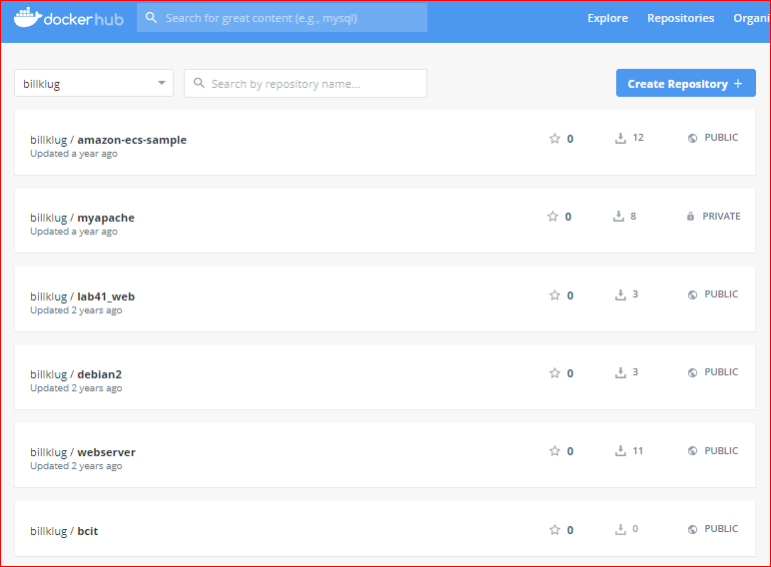

Click Explore at the top of the Docker Hub screen. These are Official images available to anyone to use. Note also, that there are over 9.5millions available images! Use the filters on the left to find a particular image.

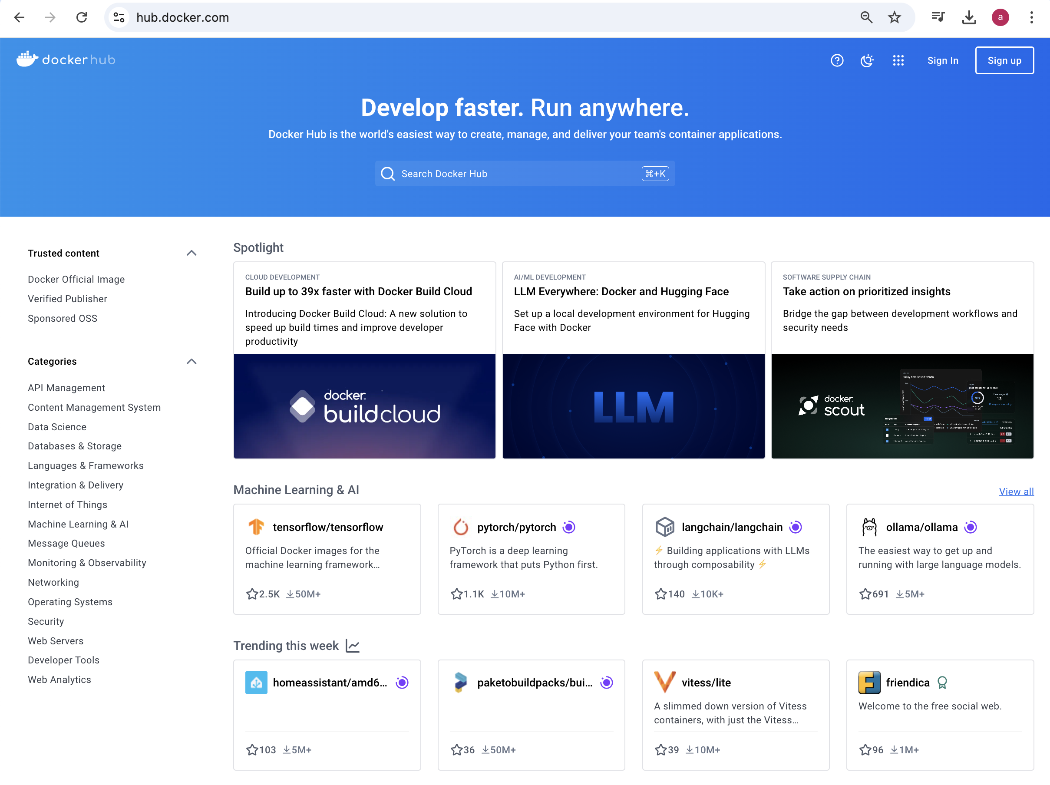

On the left, select Docker Official Image

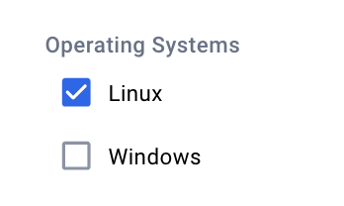 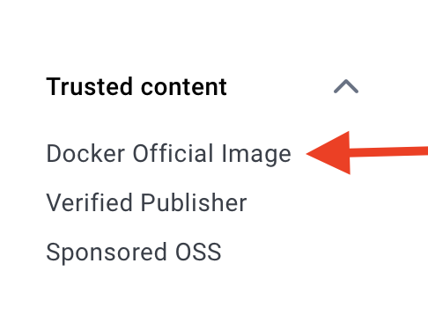

On the lower left, select “Linux” under Operating systems:

The filter at the top should only show “Linux” and “Docker Official Image”.

Deselect other filters.

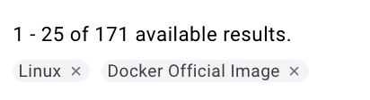

Scroll down the screen until you see the Ubuntu image:

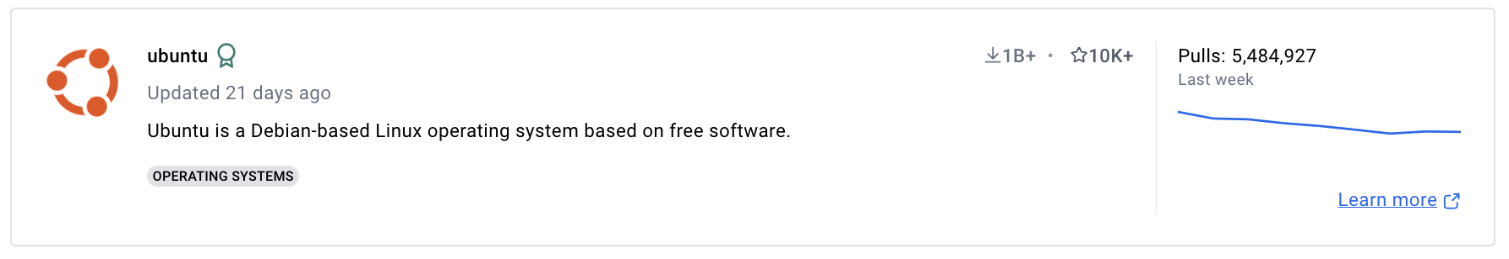

Click on Ubuntu. You should see this screen.

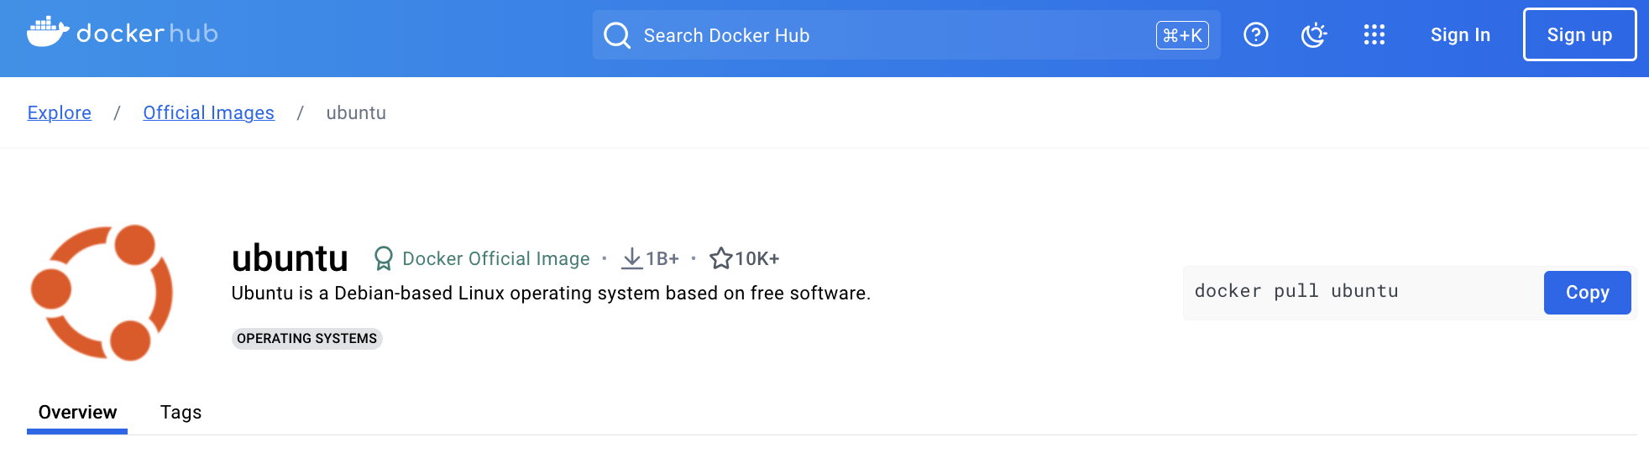

We can pull these base images with the Docker “pull” command. See the Docker Pull Command on the right:

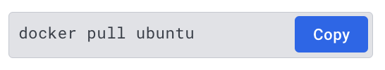

This is a base image. Base images do not run. They exist as a snapshot of the system that you can use. A container uses the files, directories and structure of the base image to run.

You need a foundation for which to run containers against.

Where do we get base images? Docker Hub and/or private repositories. This is a list of the Ubuntu base images. Click on the image listed (noble) in this screenshot below.

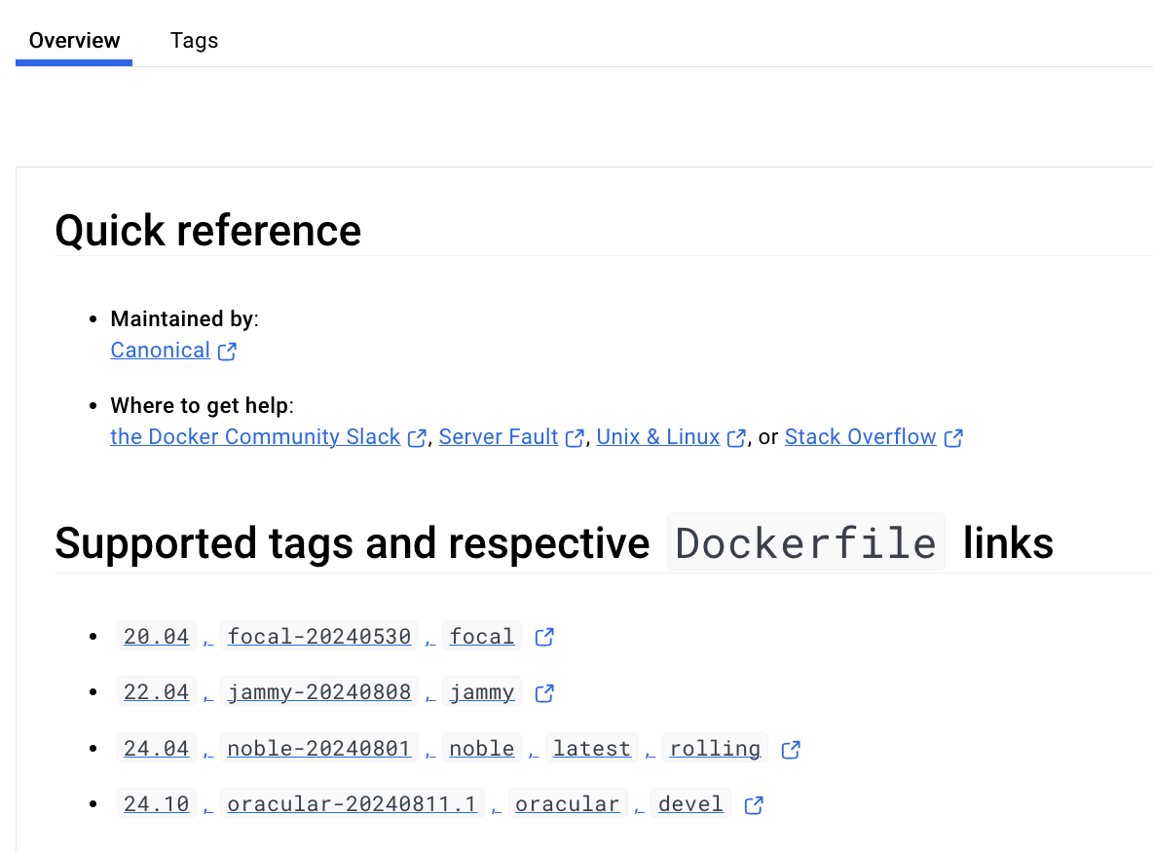

It shows an index.json file including manifests of this docker image.

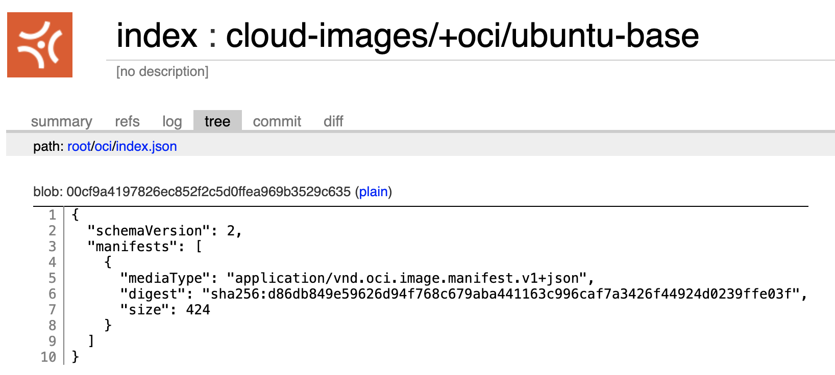

# Part 2 - Base Images

Containers are instantiated from base images. So, you download an image and then create a container from that image. Make sure you are logged into your AWS account and created a CloudShell environment. (Hint: to simplify the prompt: PS1='\u:\W\$ ' )

You can pull from both public and private repositories in Docker Hub.

“docker images” / displays local docker images

No image means we can’t run any container yet.

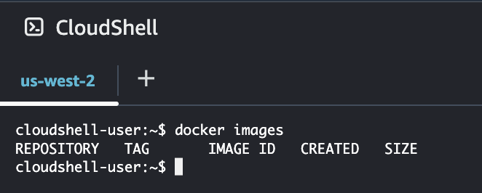

Pull an image that can be used to run a container.

Searching for images in Docker Hub. “docker search <keyword>” like CentOS or Apache.

In the screen shot, I have entered “docker search apache”. This is a partial listing.

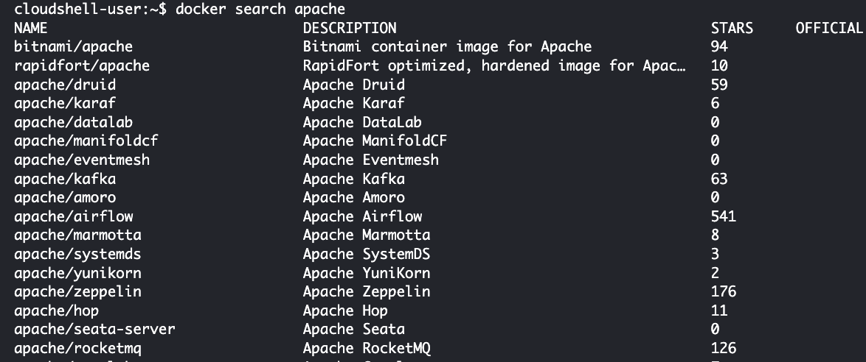

The column on the left contains the image name.

The pull command will always pull the latest version.

So, let’s give it a try. Type:

“docker pull hello-world” // Note: you will not see this image in your list.

This is a basic core OS image. This pulls one or more snapshots or digests.

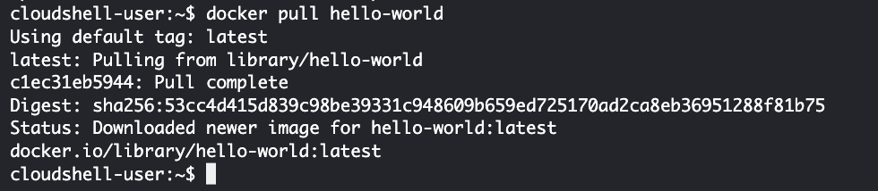

Did the image get downloaded? Do you have an image? Try:

“docker images”

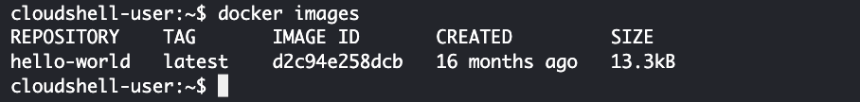

Next, let’s run this image:

“docker run hello-world:latest”

This displays “Hello from Docker!” and has created a container. It was an *ephemeral* container: It ran and then exited. Not a useful image.

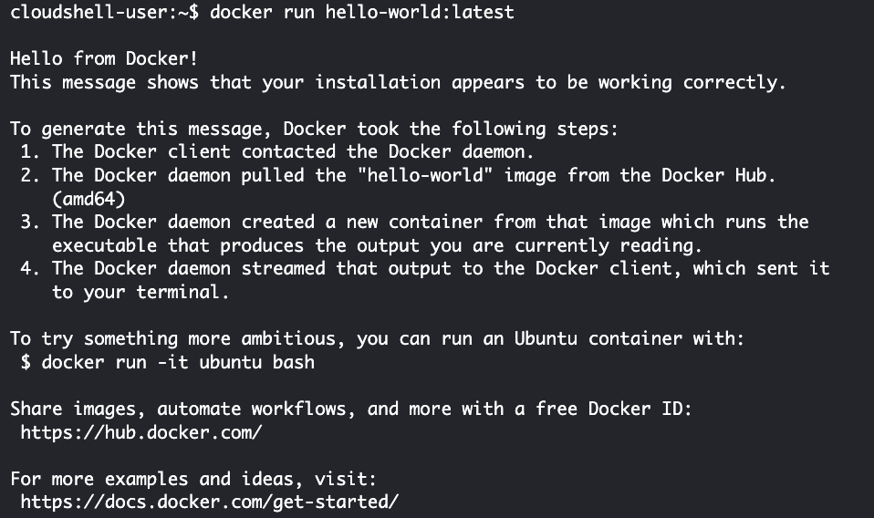

Images are referred to by both a **name** and an **image ID**.

You can run the container by the image ID.

Pull an older version (6) of centos.

“docker pull centos:centos6”

This pulls the latest version of centos:

“docker pull centos”

What are the sizes of the images?

“docker images”

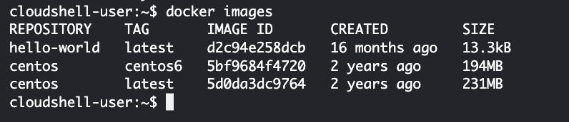

Why would I do this? Because I want to make changes to a CentOS image and publish it back to Docker Hub for other people to use.

Now, those commands just pulled a Linux image. Not very useful because nothing is installed on it. Why not pull a Linux image that has a web server already installed!

“docker search nginx”

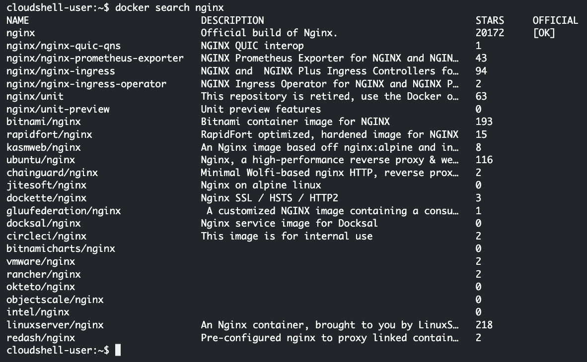

Let’s pull the first image in the list. The name is “nginx.” This pulls *multiple layers*, including the underlying operating system (Linux), the nginx engine, and the nginx configuration.

“docker pull nginx”

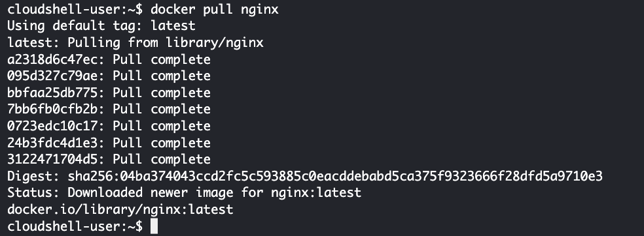

List images again with “docker images”

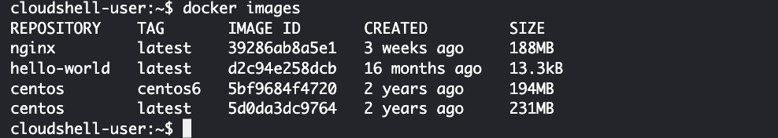

What services does an image have? What environment variables are set, path information, etc?

Ask docker to give full output of nginx image. The output is in JSON format. Use the name of the image:

“docker inspect nginx” // 7 layers

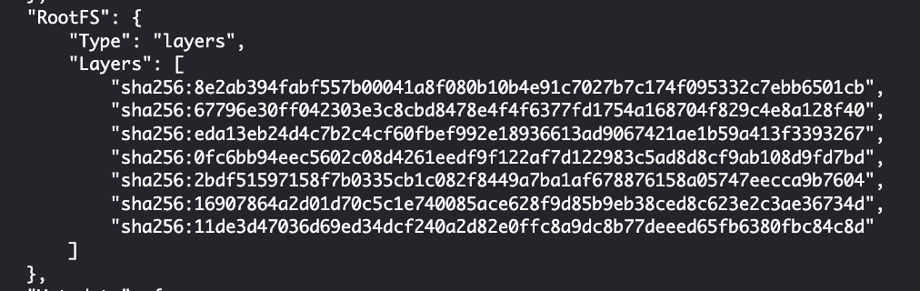

“docker inspect hello-world” //1 layer

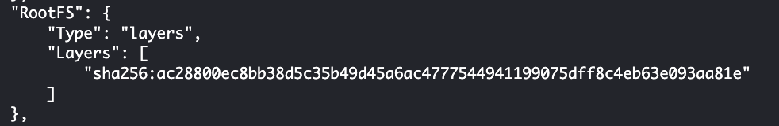

Let’s talk about what the inspect command returns.

# Part 3 - Running Containers

What do we do with the base images?

Docker “whalesay” image is used to show how containers works.

“docker search whalesay”

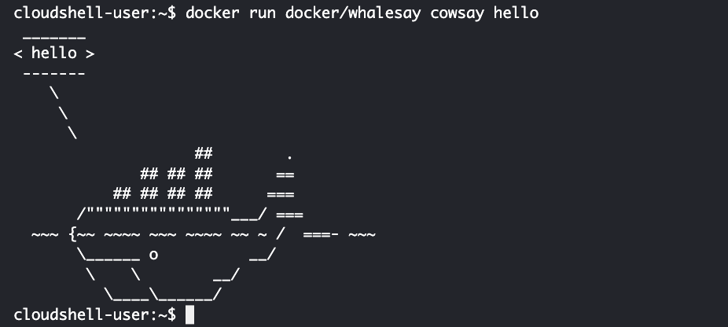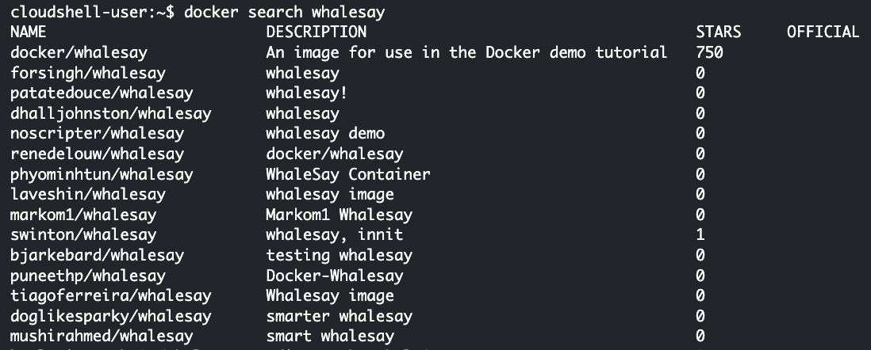

Run: “docker pull docker/whalesay”

We can run this container with a specific message.

“docker run docker/whalesay cowsay hello”

“cowsay” is the application the container is running. “hello” is the word passed as a parameter to be displayed.

Change “hello” to your name and rerun the command, and then copy & paste the result below.

|  |
| --- |
|  |

How do we tell what *containers* are running?

“docker ps” -> *process list* from within the docker daemon

If nothing is listed, it means the containers were designed to uninstantiate themselves after they ran.

Use “docker ps -a” to show containers that have been run and are in a stop state.

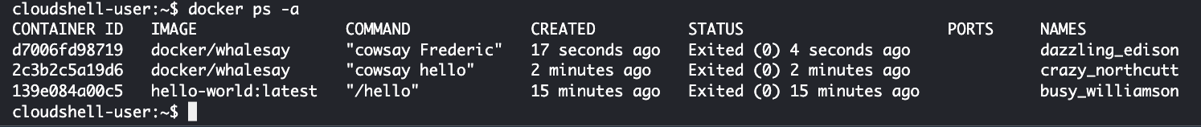

Look at the STATUS column: Exited. Each image has a container ID. The weird names, with underscores, are assigned to a container. The examples above are “dazzling_edison”, “crazy_northcutt” and “busy_williamson”.

You can run these containers using those names.

You can inspect a container using that name as well. When you inspect a container that is *not* running, you will *not* see the IP address, devices, etc. The results of an inspect on the container are a lot different than the inspect on the image.

Do “docker inspect” with name from the NAMES column.

You won’t see things like IP address (IPAddress) because the container is *not* running! But, it is a lot different than inspecting an image:

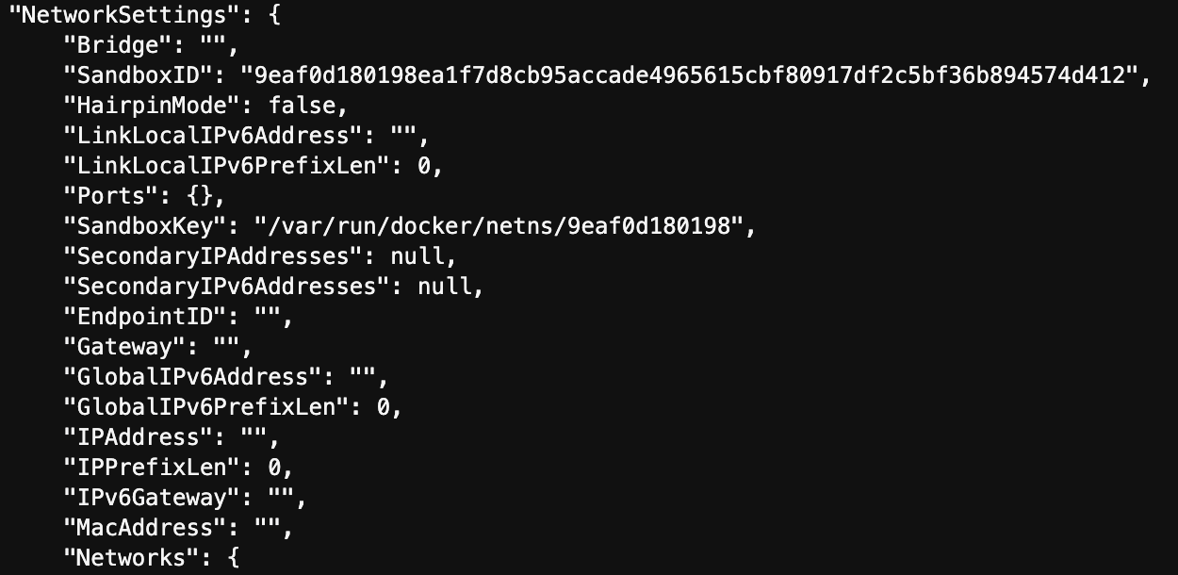

IP addresses are assigned by the automatically created **docker0** interface and the default network 172.17.0.1. This is a full Class C network: It assigns addresses from 172.17.02 to 172.17.0.254. This is the default. You can define your network to be a Class A or B network.

Run “ifconfig” in your CloudShell terminal. You will notice that there is a separate Docker interface, like a network interface card (NIC), that has been installed.

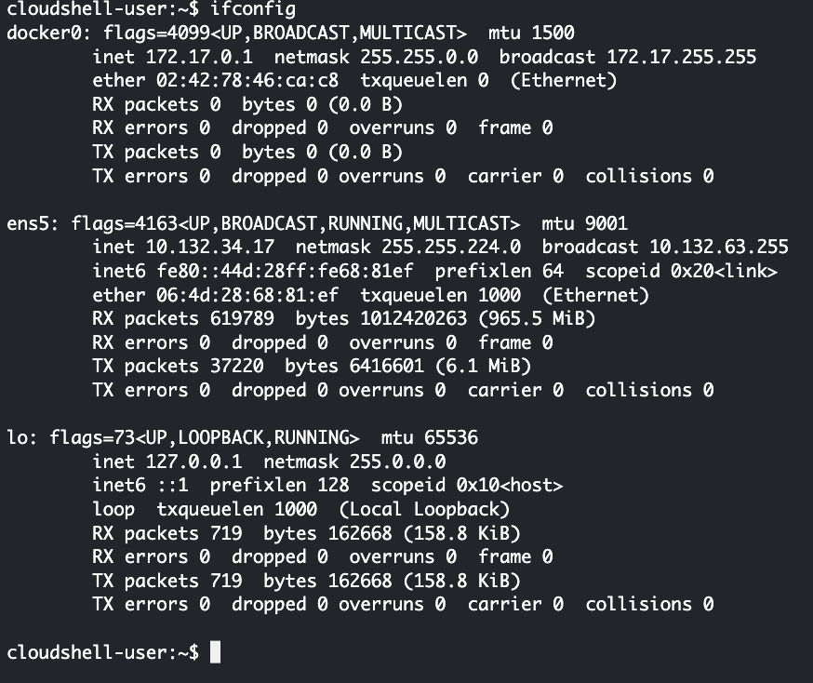

We need a running container in order for the container to get an IP address. Does this sound familiar? It should! Virtual machines (instances) get IP addresses and so do containers.

Now, we are going to run the container in interactive mode (i) and connected to the terminal (t). Connected to the terminal means “Linux shell access.” If we add a “d”, that means “run in the background, disconnected.” Then, add at the end of the command, the name of the command for the container to startup with. This will attach as Linux root user.

“docker run -**it** centos:latest /bin/bash”

Notice the prompt changes and I am ***inside*** the container running as root.



Now, you can run Linux commands, like “yum upgrade.” (Try it. Does it work?)

The container is *not* a full operating system (OS). You don’t have system tools like SSH or Telnet.

The only command currently running is /bin/bash. Leave this running. Do NOT exit the container.

Open another terminal window within your CloudShell environment.(Hint: PS1='\u:\W\$ ')

Run “docker ps” to see the container running.



Return to the prompt running the container computer and exit the container, exit is the command.

Now, from the second command prompt, the container is not running any more.

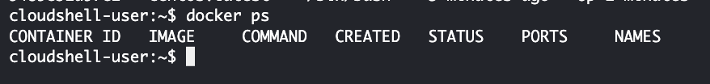

To run a container in the background: You will *not* be logged into the container.

“docker run **-d** centos:latest /bin/bash”

If you run “docker ps,” you will not see a process running, same as above.

Let’s run the webserver nginx. It should start the Nginx web server. Will it be available? Yes.

“docker run **-d** nginx:latest”

Notice it is running in the background:

“docker ps”



Is a port open? What port? What does that mean?

Do a “docker inspect <container name>”

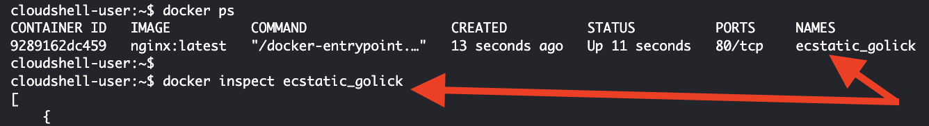

Write down the IP address. My IP address is 172.17.0.2

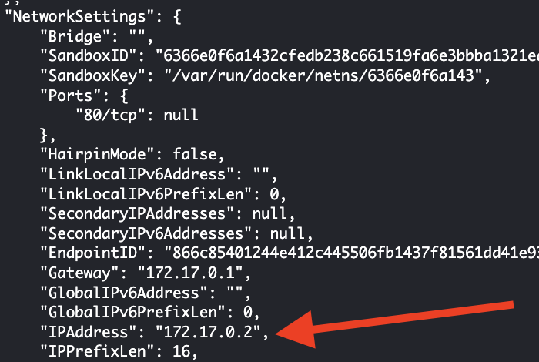

Ping the IP address: “ping 172.17.0.2” (You are pinging from your instance into the running docker container.)

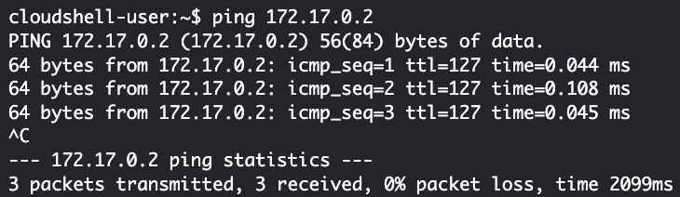

Should I be able to view the web page?

When you do “docker ps” it shows the open ports (80). Does that mean I can view the web page?

You should still have two SSH connections or terminals to your AWS instance.

From one of your connections, install elinks: “sudo yum install elinks -y”

Elinks is a text-based web browser.

Then run: “elinks <http://172.17.0.2>”

Remember: 172.17.0.2 is the IP address of my container. Success!

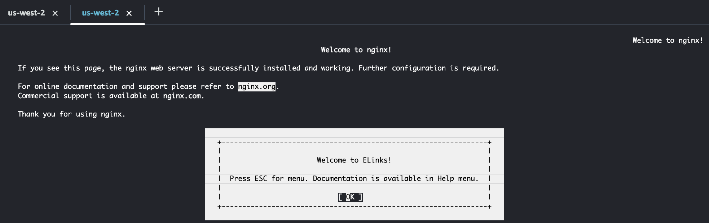

Hit “CTL-C” to exit.

Test with telnet on port 80:

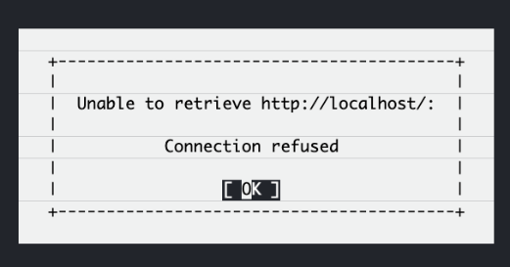Port 80 isn’t doing anything on the host system, to see it is ONLY running on the container.

Install telnet: “sudo yum install telnet -y”

Run: “elinks <http://localhost> ”

Did anything happen? “Connection refused” is expected.

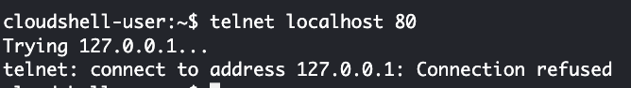Now, if do “telnet localhost 80” and you won’t be connected. “Connection refused” is expected.

Now do this:

“telnet 172.17.0.2 80” (Hint: use your ip, may or may not same as mine 172.17.0.2)

If you get this screen, it means you have connected:

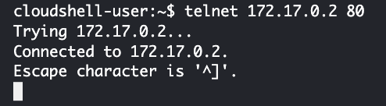

Run “docker stop <container name>” on the nginx container

“docker ps”

“docker ps –a”

Assign your own name “MyWeb1” to a container. You can’t reuse names.

“docker images”

“docker run -d --name=MyWeb1 nginx:latest” // two hyphens in front of “name”

“docker inspect MyWeb1”

“docker ps”

“docker stop MyWeb1”

“docker ps”  
How can I access containers running on a host?

You can create static IP addresses, or you can run a front end container manager, like **Kubernetes**, that can manage IP addresses, load balancers, etc.

# Part 4 - The Container Lifecycle

Containers have a lifecycle associated with them: Run, stop, restart, etc.

“docker ps”

“docker ps -a” //history

“docker images”

Remember running a container in background mode?

“docker run **-d** --name=LifeCycle1 nginx:latest” // two hyphens in front of “name”

“docker ps”

You can now *attach* to this container:

“docker attach LifeCycle1”

But, because we didn’t specify to run “/bin/bash,” you *will not* get a prompt or anything. It looks like you are just hanging there. I’m attached to the process running the container, not a command line interface.

What happens if you do a Ctl+C? You kill the container. You’re stopping the process. To verify the container is dead, run “docker ps.”

Container restart:

“docker start LifeCycle1” // or restart

“docker ps”

Attach to container, but I don’t want it to exit.

“docker **exec** -it LifeCycle1 /bin/bash” // this executes something in the running container

You should be inside the container. Check to see if nginx is running:

“ps aux | grep nginx”

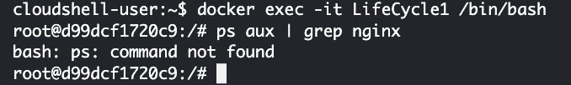

If the “ps” command doesn’t work, then run this:

apt-get update && apt-get install procps

Rerun “ps aux | grep nginx”

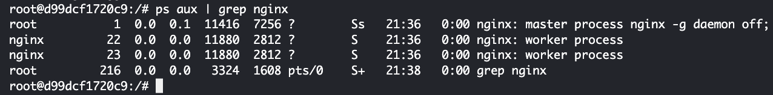

Now, what happens if I exit the container? In this case, the exit doesn’t stop the running container. Run “docker ps.” LifeCycle1 is still running.

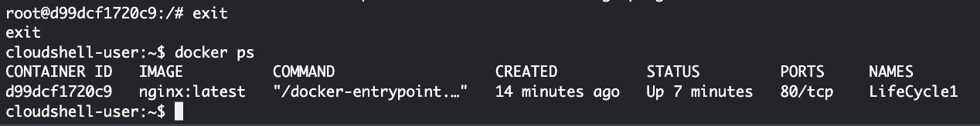

So, I can do something while the container is running, exit the container, and it keeps running.

To stop the container: “docker stop LifeCycle1”

Then do a restart.

# Part 5 - Image and Container Management

We have both images and containers. A container is a full snapshot, including the base image.

How do we deal with images and containers that are no longer needed?

“docker images”

To remove container images, we will use the “**rmi**” or remove image parameter in our Docker command. In this case, the image has *not* been used to create a container.

“docker rmi centos:centos6”

Notice that it is deleting the layers of the container!

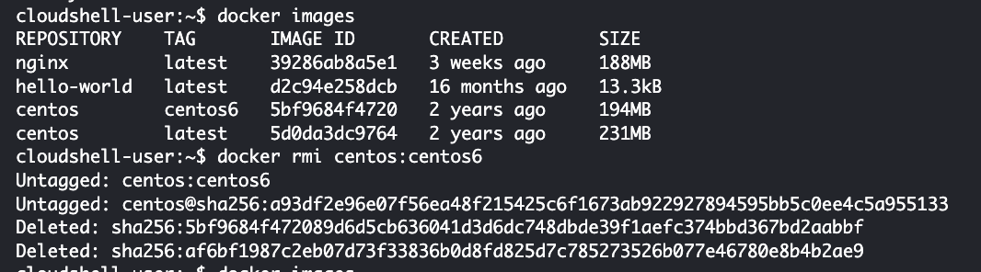

What if the image has been used to create a container?

“docker rmi hello-world”



We could force, but we’re ***NOT*** going to do that:

“docker rmi **-f** hello-world”

We can’t do it. The containers are still there but not running.

“docker ps -a”

First, remove the containers that are dependent on the base image

Use the container ID and the command “rm” not “rmi” (Diff: with or without “i” at the end)

“docker rm <container ID>”

Then delete the image. But, in the case of “hello-world” you still get an error. Why?

There must be another container based on that image.

But, what if I have a lot of containers based on an image?

To remove all containers, you can pass a command line into the docker rm command.

docker rm `docker ps -a -q` //notice the two back-ticks, not single quotes

The command “docker ps -a -q” returns a list of container IDs, each is passed into the rm command.

At this point, I have no containers: Run both “docker ps” and “docker ps –a.”

But, I should still have images if I run “docker images.”

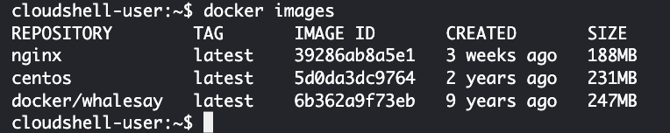

If I don’t, what can I do? Download a new image!

Now you may go back and run an “rmi” on the image. *Don’t* delete any images at this time!

# Part 6 - Redirection – Ports and Volumes

Ports are exposed by the container through the Docker config file.

You can connect to a port through the container IP address. But the ports to be exposed as part of the Docker file.

However, there is a routing problem of the server that contains the container. Normally, you would have to add a static route to the container. We want to avoid that. We want to avoid routing tables, etc.

So, in the case of the nginx container, we want to direct port 80 to a port on the *underlying host*. What is our underlying host? (Answer: Either the Centos Linux instance or the CloudShell Linux instance.)

“docker run -d nginx:latest” // What does this do? Read above if you don’t know by now.

“docker ps” will list the ports that are exposed, i.e., 80 and 443. Exposed through the IP address.

“docker inspect <container name> | grep IPAddr”

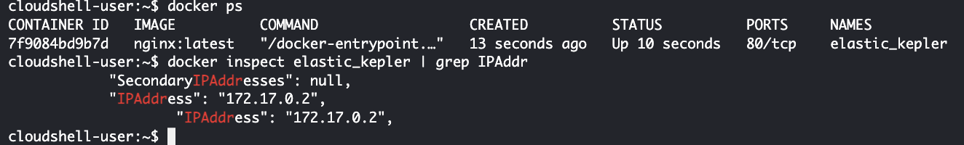

Side note: for this inspect command, we may use container name or id, and we don’t have to type in the full ID sequence as below:

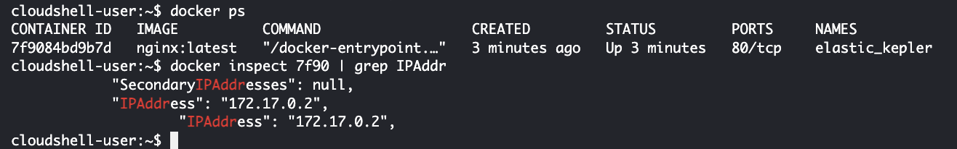

This next command should work because we are running the IP address assigned to the container: “elinks http://172.17.0.2”

But, this won’t work for localhost. (as “Connection refused” shown)

“elinks http://localhost”

Nothing running on localhost, i.e., your CloudShell instance.

You can redirect exposed ports to localhost in such a way that you can connect to them. Two ways to do that. First, run then next four commands. We want to start with a new container.

“docker ps”

“docker stop <container>”

docker rm `docker ps -a -q` //remove all previous containers

“docker ps -a”

“docker images”

The -P parameter, below, makes any exposed ports available to the localhost. It will assign the ports randomly (not the best):

“docker run -d --name=WebServer1 **-P** nginx:latest”

“docker ps” will show the ports



In my case, Port 32768 is bound to all local interfaces. You might see different port number.

Now, do “elinks [http://localhost:<port](http://localhost:%3cport)>”



It works!

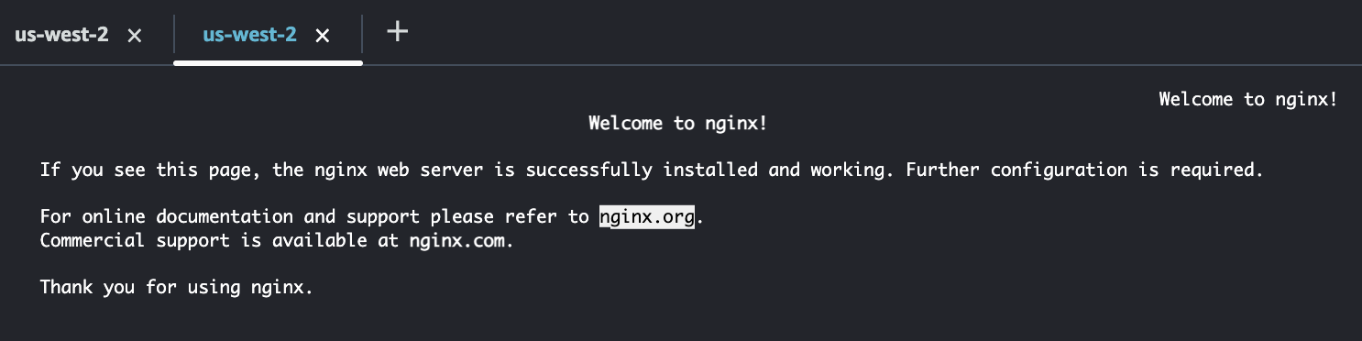

However, it is still not accessible to the outside world, only the local host.

“docker port WebServer1 $CONTAINERPORT”

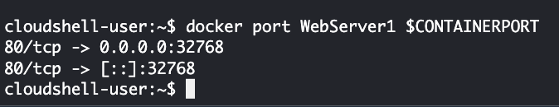

Now, let’s stop this container and start a new one that maps the container port to a port on the host so that we can access the Nginx home page.

“docker stop WebServer1”

Binding to a specific port on the host:

“docker run -d **-p 8080:80** --name=WebServer**2** -P nginx:latest”

Notice: there is both a lowercase ‘p’ and an uppercase ‘P’.

“docker ps”

Notice I am now mapping port 8080 to port 80:



Then test.

“elinks <http://localhost:8080>”

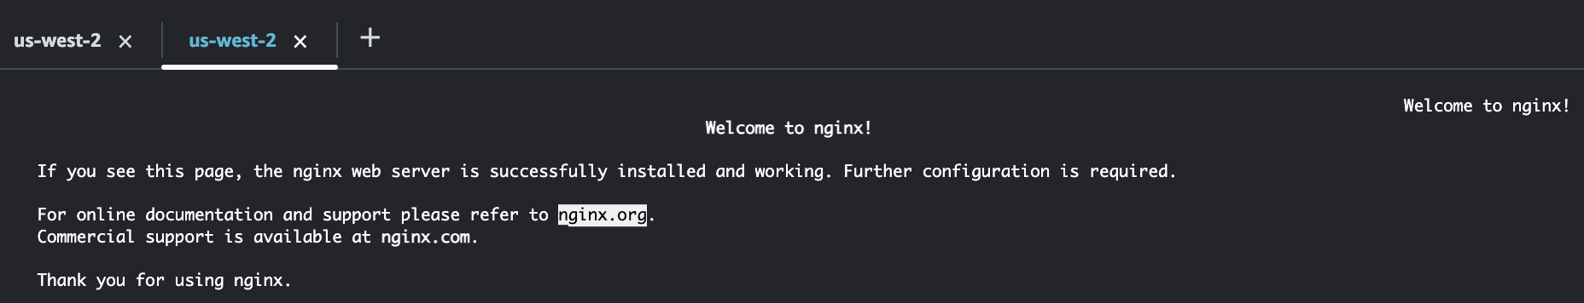

**Your challenge:** *Display this same web page using the Public IP address of your instance!* This is my instance Public IP address:



This is the web page displayed in my browser using the public IP address of 34.209.210.195:

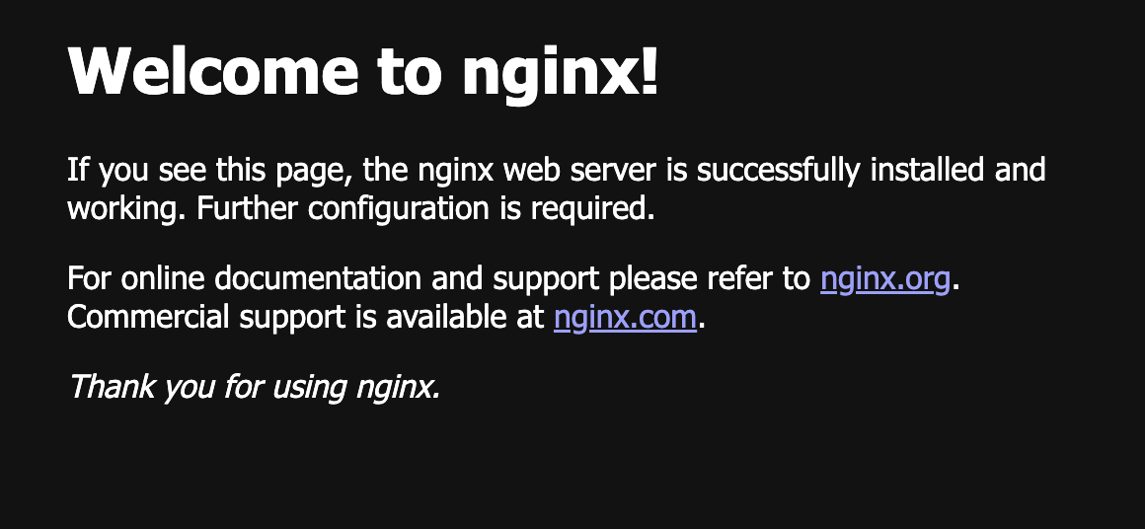

Hint 1: What is the default port most web servers run on, including Nginx?

Answer: 80

Hint 2: What does this command line parameter mean: “**-p 8080:80**

Answer: map port 80 to 8080

Hint 3: When you can’t display the home page of a web server running on an EC2 instance, what is the usual problem?

Answer: Security group settings/ACL

Once you get this working, then you can stop this container:

“docker stop WebServer2”

This is useful because you don’t have to worry about routing.

Now, we can pass stuff from the host into the container without copying into the container either during build time of either the base image or container.

You can mount directories from your underlying *host* from within the container. There are a couple of ways to do this.

Go to the root directory of your CloudShell instance (“cd /”) Run “ls” command.



There is a directory called “mnt” which stands for “mount.” If you go into that directory, it should be empty. We are going to give the container access to the directory the mnt directory.

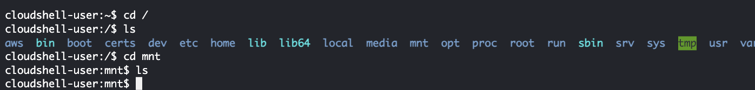

To run a container that mounts a specific directory:

“docker run -d -p 8080:80 --name=WebServer**3** **-v** /mnt/data nginx:latest”

The mount point /mnt/data will be created inside the container. You can then **exec** into the container and see the directory ‘data.’

“docker **exec** -it WebServer3 /bin/bash”

Navigate to /mnt/ directory and see **data**.

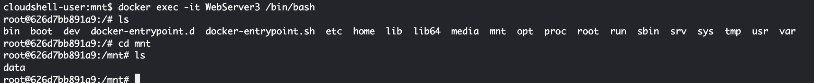

Exit the container and run “docker stop WebServer3”

A container should be as ephemeral (portable) as possible. Stuff should be intended to stick around.

On your CloudShell instance, navigate to the **/home/cloudshell-user** directory.

“mkdir www” [on the host]

“cd www”

Create a website home page: touch index.html [default web page loaded by nginx or apache:]

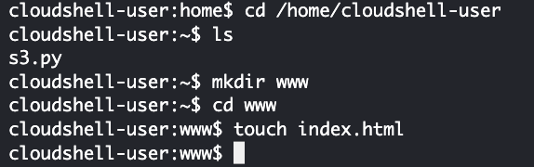

Create a simple web page with your name.

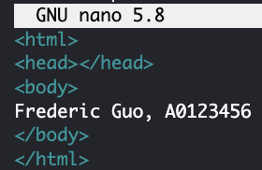

Now, mount this to the nginx default web folder in the container: /usr/share/nginx/html

“docker run -d -p 8080:80 --name=WebServer**4** -v /home/cloudshell-user/www:/usr/share/nginx/html nginx:latest”



“elinks <http://localhost:8080>”

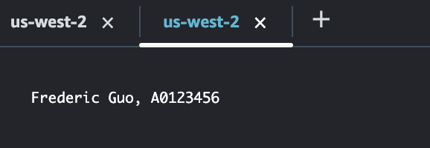

Now, let’s make a change to the web page on your host. You don’t have to change the container. It will display the new information.

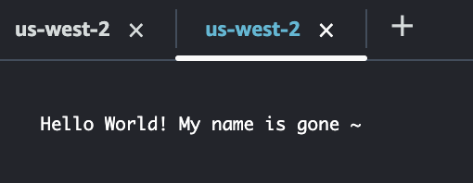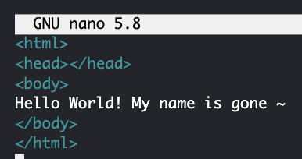

In the next section, we are going to look a creating an image configuration file using a Dockerfile. An important question to answer is this: How can I create a Dockerfile that copies my custom home page (index.html) from my hard drive and bake it into my Docker image? We did this manually, above, but once the container is deleted, the image doesn’t contain our homepage.

# Part 7 - The Dockerfile

First, clean up everything as follow:

“docker stop WebServer4”

“docker rm `docker ps -a -q`”

You should just have images and no containers (processes).

Creating your own base image. It will be based on another generic base, like an operating system.

To do that, you will build a Dockerfile.

The Dockerfile sets up a script that will build a base image following a list of instructions.

Navigate to your home directory: “cd /home/cloudshell-user”

Create a Builds directory on your AWS instance: “mkdir Builds”

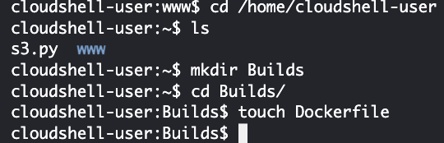In that directory, create a file called “Dockerfile”. *This is case sensitive, capital ‘D.’*

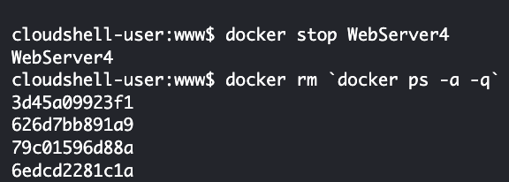

Edit the Dockerfile. We are going to add commands to build our own image.

FROM debian:stable

MAINTAINER fredericguo <Frederic_guo@bcit.ca>

RUN apt-get update -y

RUN apt-get upgrade -y

Where is the base image coming from? The FROM statement answers that question.

The FROM statement will look locally first (your computer), then the public repository.

*The MAINTAINER line has your Docker Hub account and email address.* Not required because we are storing this locally at this time.

RUN runs the command directly after it, exactly the way you write it. So, you might get an error if it is typed incorrectly. The RUN command will execute using root privileges.

FROM debian:stable

MAINTAINER fredericguo <Frederic_guo@bcit.ca>

RUN apt-get update -y

RUN apt-get upgrade -y

Save the Dockerfile. Run this command to build your image. The dot says pull the file from the local directory.

“docker build -t fredericguo/myapache **.**” // do not miss the dot at end of line

How many layers are created? This is a partial screenshot:

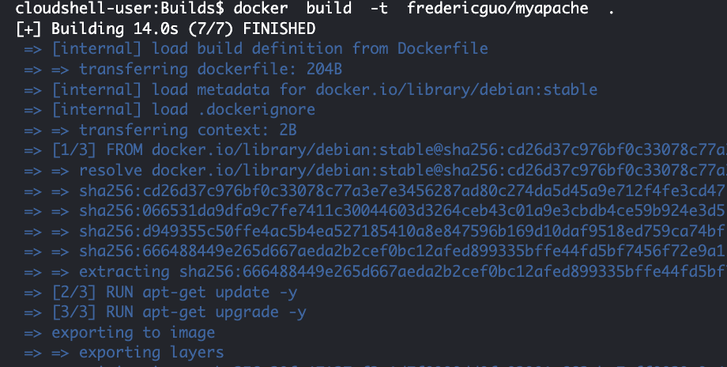

Run: “docker images”

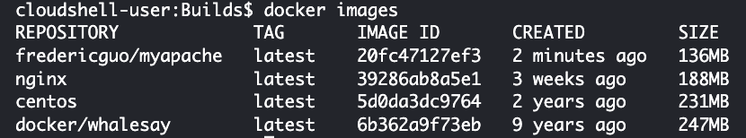

Now, change the Dockerfile by adding “RUN apt-get install telnet” and run the build command again.

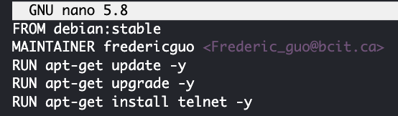

When we do the build commands, the steps that get displayed are containers being built.

So, there are several of them. But there are more than we really want. The individual RUN commands are building layers. So, we want to combine commands.

Edit Dockerfile and *remove* telnet install command.

Rebuild went fast! It uses cached copies. In other words, it went back to our original image (layer) before we installed telnet.

Each individual RUN command builds a separate layer, so we only want to have one RUN command so that we don’t have so many layers.

Best practice is to combine the packages on a single RUN command, like this. Enter this line in your Dockerfile:

RUN apt-get update && apt-get upgrade -y && apt-get install -y apache2 telnet elinks openssh-server



The double ampersand says “Only continue to the next command if the previous was successful.” It will give you an error message if it can’t install a package.

Now, you should only see Step 3 execute when you build the image. (If not, don’t worry about it for now. Just make sure in builds.)

Adding an environment variable. We can pass a value into the container for this environment variable.

Open the Dockerfile, add an environment variable called MYVALUE

ENV MYVALUE my-value

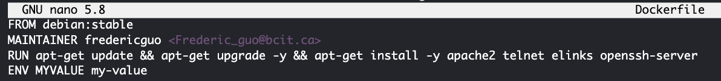

“docker build -t fredericguo/myapache .”

“docker run -it fredericguo/myapache:latest /bin/bash”

From inside the container, run “echo $MYVALUE”

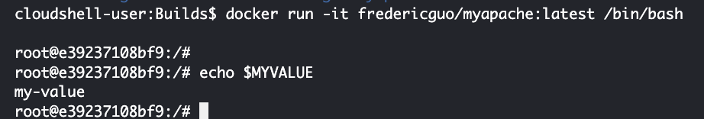

Exit the Docker container: “exit”

Remove all docker containers: docker rm `docker ps -a -q`

Adding ports to a container. This is like creating a security group for an AWS instance. It answers the question: What ports should I expose to the outside world?

Open the Dockerfile.

Expose port 80 and 22 with following two lines:

EXPOSE 80

EXPOSE 22

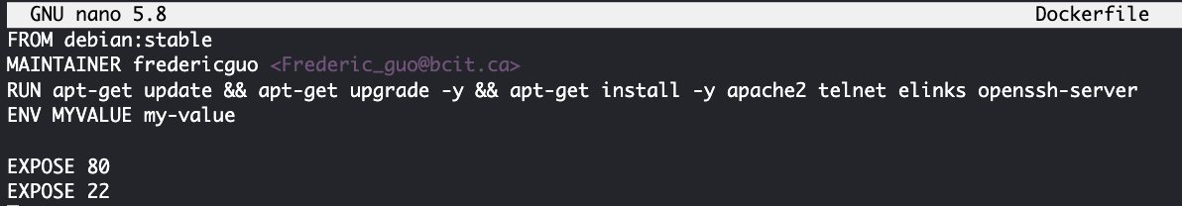

Build and then run the container (/bin/bash)

docker build -t fredericguo/myapache .

docker run -it fredericguo/myapache:latest /bin/bash

Go to another terminal tab and notice that the ports are exposed.

Run: “docker ps”



So, you should be able to get to the container using the container IP address. That is, you should be able to SSH into the container from another machine. But it’s beyond the scope of this lab.

Exit from the container and remove the container that was created.

“docker rm `docker ps -a -q` ”

Next, we want to start a service after we install a package. For example, starting nginx from inside a container. This should be familiar to you! Same idea as building a Chef recipe file.

Add this to the Dockerfile file. Example: start apache. Remove port 22. See screenshot below.

Need to run a CMD.

**RUN** – This is executed when building the base image

**CMD** – Done after container is built. This is executed when the container is run, not when the base image is built.

CMD ["/usr/sbin/apache2ctl", "-D", "FOREGROUND"]

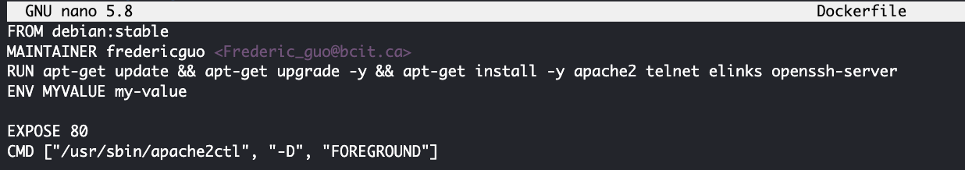

This CMD says, “start apache, don’t run in daemon mode, and run in the foreground”.

This is a simple list.

Build and then run in disconnected mode:

docker build -t fredericguo/myapache .

Now, when we run the container, we don’t need interactive mode or access into the container. We can run disconnected mode.

docker **run -d** fredericguo/myapache:latest

Use “docker inspect” to find out the IP address:

“docker inspect <container name> | grep IPAddr”

Then elinks - should display the Debian home page

“elinks <http://172.17.0.2>”

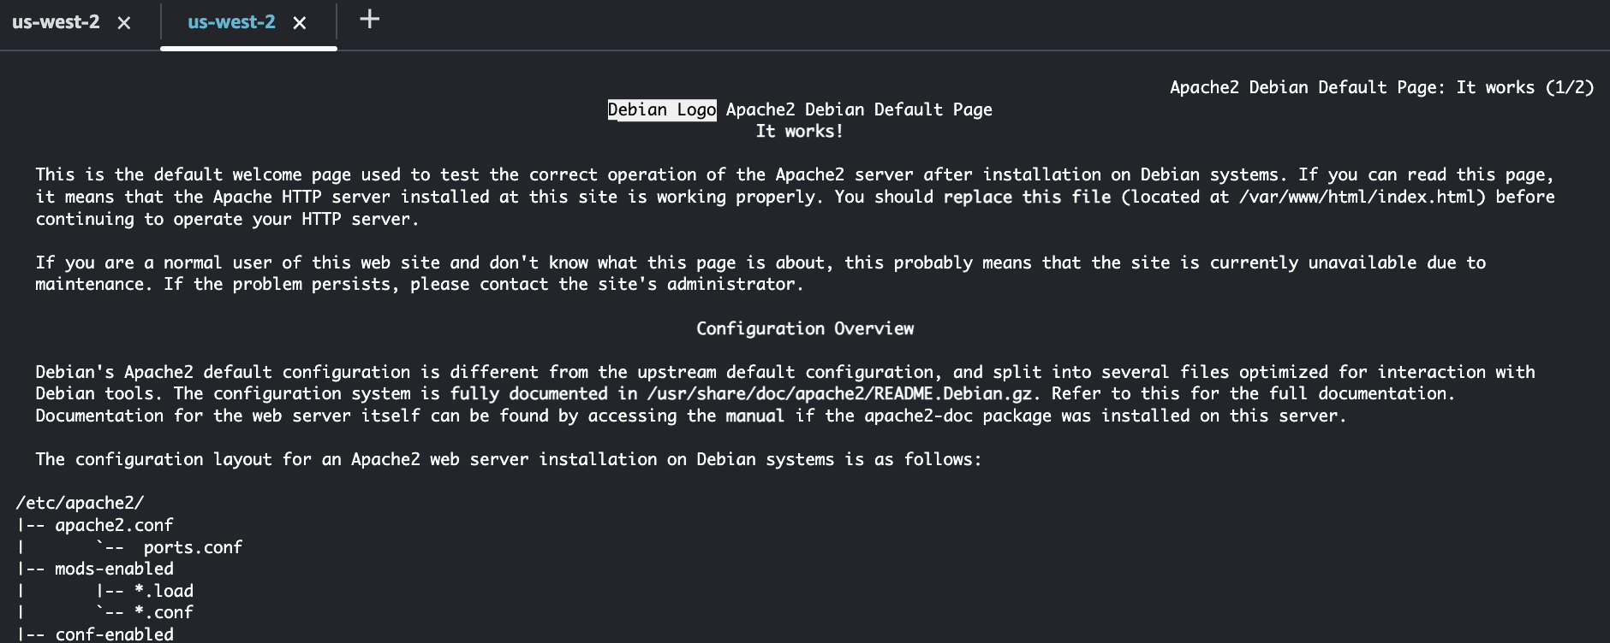

An important question to answer is this: How can I create a Dockerfile that copies my custom home page (index.html) from my hard drive and bake it into my Docker image? We did this manually in the previous section but once the container is deleted, the image doesn’t contain our homepage. Hint: Research the use of the WORKDIR and COPY commands.

Note: this is not mandatory for this lab, however, it’s required for your assignment(s), midterm and final exam.

# Part 8 - Docker Hub

You should already have a Docker Hub account.

Back to your docker website, then go to the docker hub.

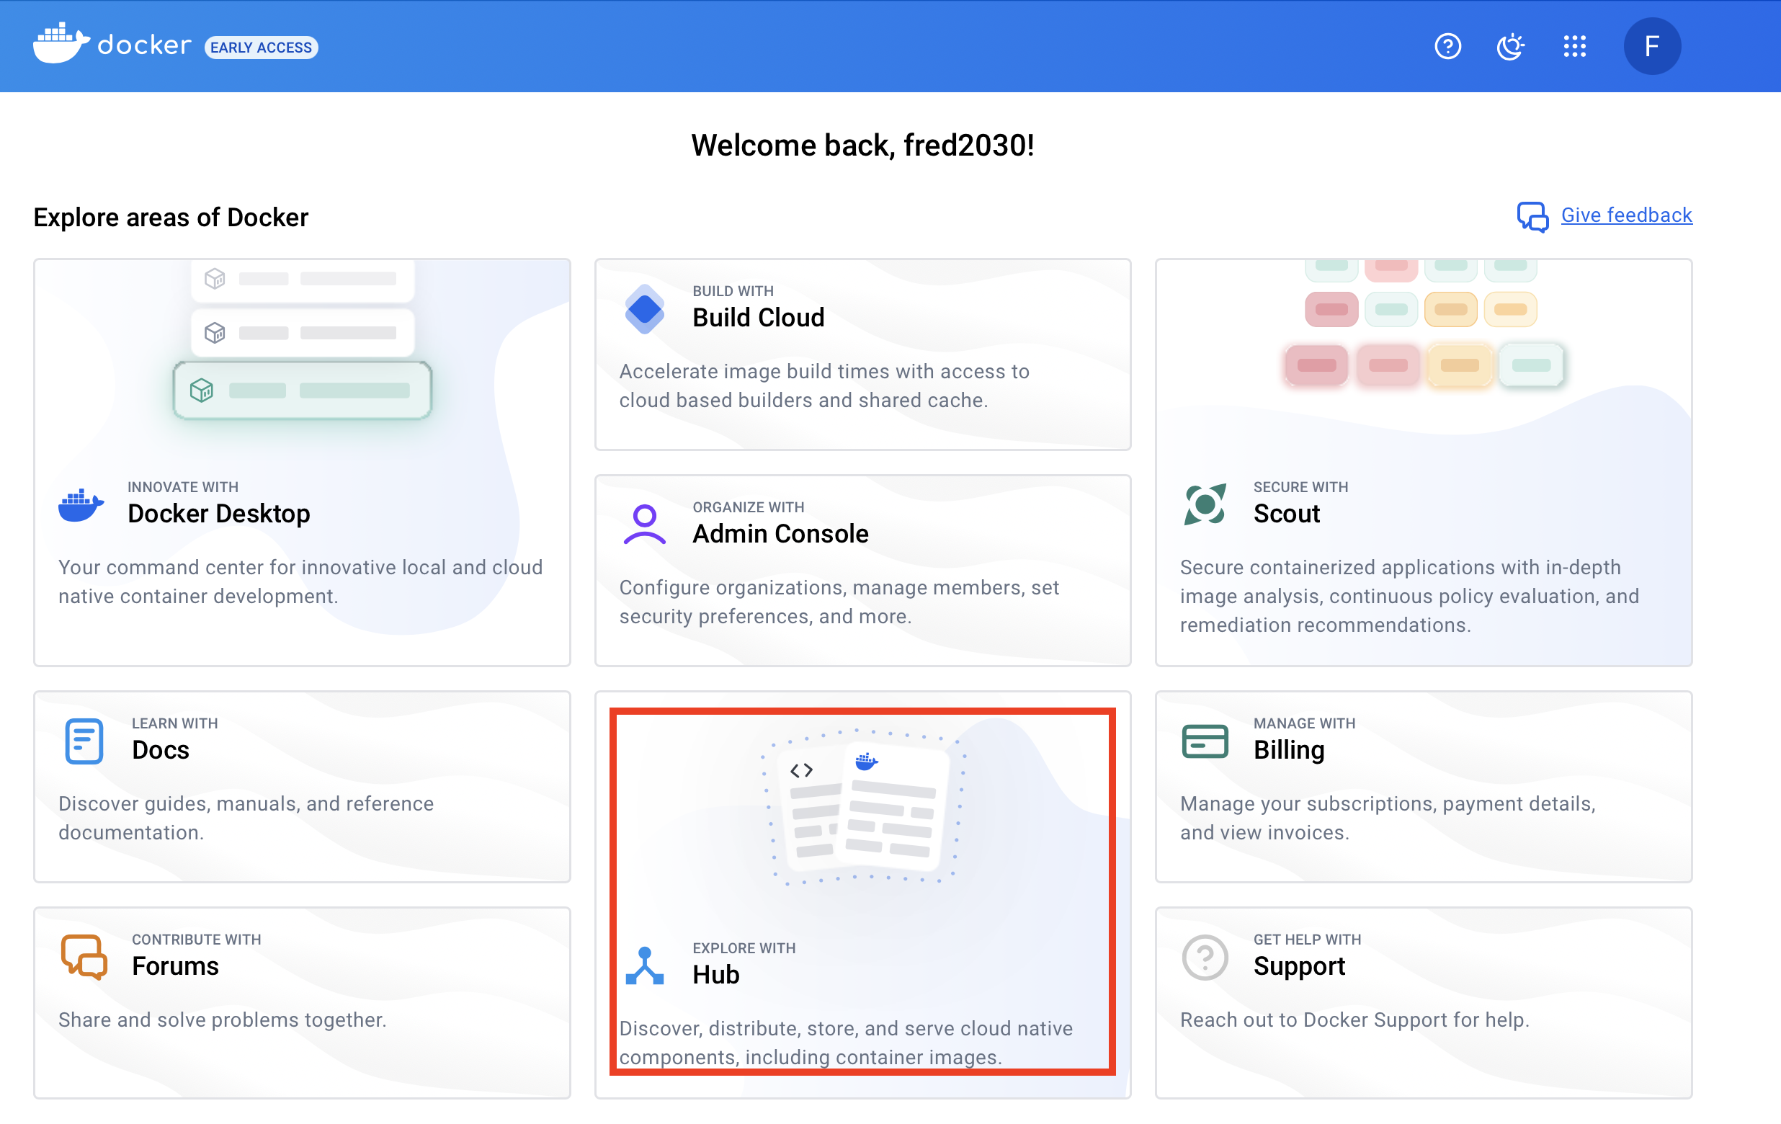

Create a repository called “myapache” in your Docker Hub account. Make the repository public.

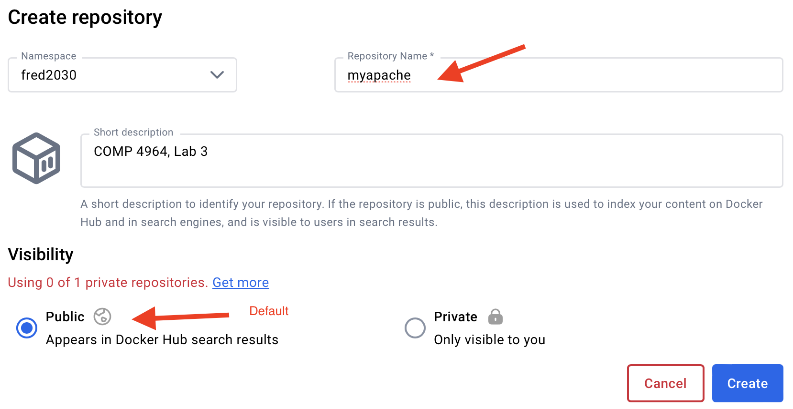

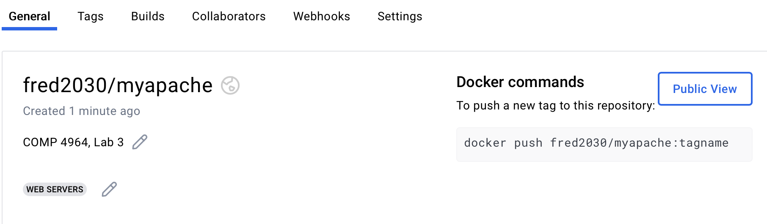

Note: I selected “web servers” category.

Since my docker account named “fred2030”, I rebuild my image with that prefix.

In your CloudShell instance, list your images.

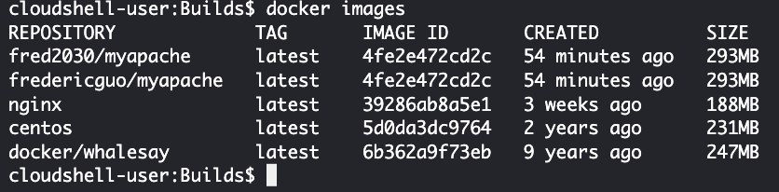

Tag your Apache image, e.g., fredericguo/myapache, to be version 1.0.

“docker tag <**image id**> fred2030/myapache:1.0”

List your images.

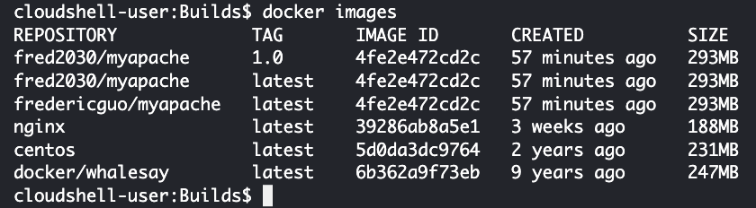

Log into your Docker hub account *from the command line:*

“docker login”

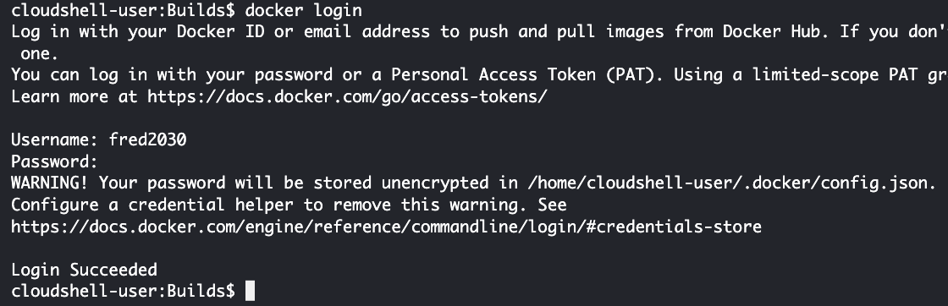

Push your image to your Docker repository:

docker push fred2030/myapache

docker push fred2030/myapache:1.0

“fred2030” is the name of my Docker Hub account. “myapache” is the name of the image that I’m pushing to my account. Please push to *your* Docker Hub account, not mine!

Verify the push worked. Notice version 1.0. (From your web browser, log into hub.docker.com.)

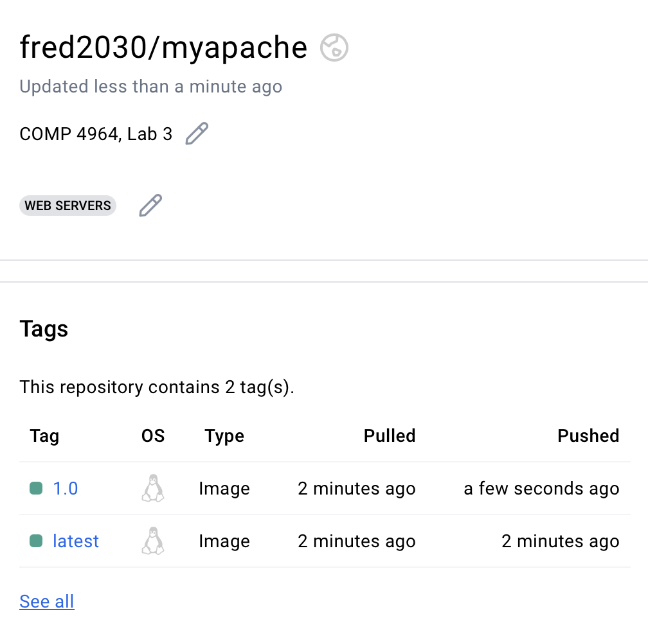

Remove the image (fred2030/myapache:1.0) from your host machine:

“docker rmi <image_repository_name>:1.0”

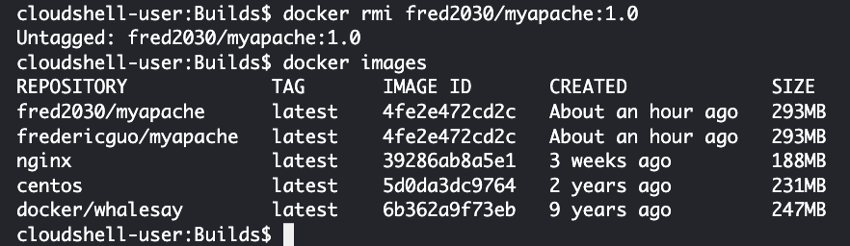

Download your image from you Docker repository:

“docker pull fred2030/myapache:1.0”

“docker images”

Verify you can create a container from the image:

“docker run -d fred2030/myapache:1.0”

“docker ps”

Use “docker inspect” to get the IP address

“docker inspect <container name> | grep IPAddr”

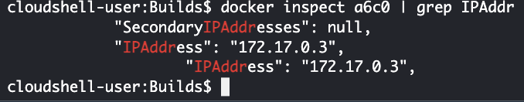

Then elinks - should display the Debian home page

“elinks http://172.17.0.3”

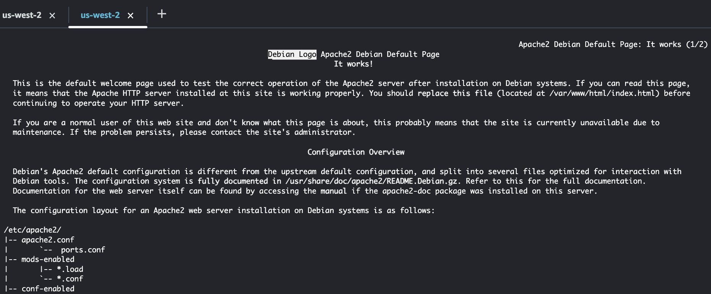

Assignment/Deliverables

1. Create a Dockerfile that builds a Docker image. The Docker image should install a webserver, like NGINX or Apache. The home page of the web server should display your name and A00 number. Hint: You may have to use the following two Dockerfile commands: WORKDIR and COPY.

Make a screenshot of your Dockerfile contents and paste it below:

|  |
| --- |
|  |

1. When you build and run a container from the image, you should be able to see the home page by running elinks or http://localhost. The home page should display your name and A00 number. Make a screenshot of your page in a browser and paste it below:

|  |
| --- |
|  |

1. Tag your image and upload it to a public repository in your Docker Hub account.
2. Make a screenshot and paste it below. It should include the name of your Docker Hub account and the repository. Example: fred2030/myapache

|  |
| --- |
|  |

I will download your Docker image, create a container from that image, and see if your home page appears. This is what I should see when I run elinks against your container. (Except, your name and A0 number, not mine.)

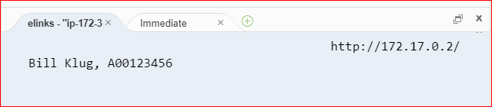

Your CloudShell environment does *not* have to be running for me to mark your lab.

Clean Up

We are going to do more Docker labs. I would suggest that you simply delete all Docker containers and images.

Delete your CloudShell environment.

